Vizard practicum week 2 B

Course: VR3D
Version: 1.4
Author: Michael Schifferling
Patrick de Beer (Unity Add-on)

Introductie:
This practicum will focus on the use of textures. We’ll take a look at several techniques how textures can be used in Vizard

For the Unity instructions go here.

Tutorials:
Exucute the following Vizard Tutorials
- Applying Textures
This tutorial will teach you how to use basic textures in Vizard.

Assignment: Scene with textures
Create a new Vizard project. Create a few new 3d models (with Wings3d for example) and add these to the scene.
Take the following into account:
- One object has to use a non tiled (clamp) texture. For example a painting on a wall
- One object should use a tiled texture (wrap). For example a brick wall.
- One object should use a mirrored and tiled texture.(W rap mirror). For example a mosaic floor.

Assignment: Cube on the fly with textures.
Add your on the fly parametric cube from the previous practicum assignments to the Vizard scene, and try to attach a texture to this cube.
What do you see?
……………………………………………………………………………………………………………………………………………….
……………………………………………………………………………………………………………………………………………….
……………………………………………………………………………………………………………………………………………….

Assignment: Brick your generated cube
The problem you described above can be fixed by assigning texture coordinates when defining vertices. Adjust your cube generating code so each side of the cube uses the entire texture. To do this use texcoord (u,v). The coordinates of every vertex on each side should be in the range 0..1 in both U and V direction.
For example, this texture
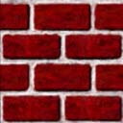
has to be mapped on each face of the cube, giving this result:
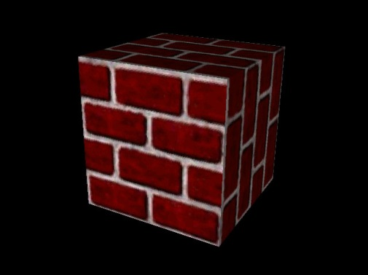

Assignment: Make your generated cube look like a dice
Make your cube that looks like a dice, using a downloaded texture, like the one below:
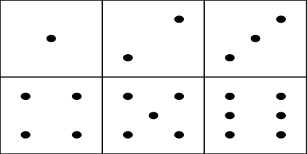
The end result should look something like this:
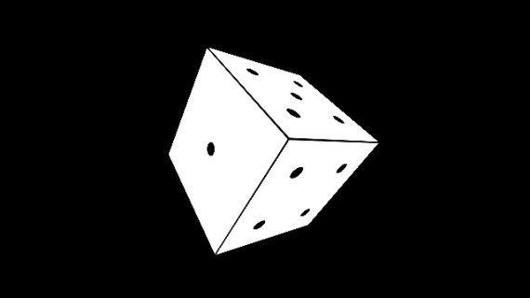

Optional: Unity practicum week 2b

Instructional Links
These links might help you getting started:
- http://answers.unity3d.com/questions/154324/how-do-uvs-work.html
- http://docs.unity3d.com/ScriptReference/Material-mainTextureScale.html
- https://docs.unity3d.com/Manual/class-TextureImporter.html

Assignment
The Unity assignment is basically the same as the Vizard one, so read and perform the Vizard assignment above, making the appropriate changes (like replacing “Vizard” by “Unity”) as necessary.
Note that a texture can be added to a Material as Albedo map.

